**Excited trion states and symmetry**

We are interested in a positively charged hot/excited trion state (two holes occupying different levels and an electron in a ground state). We are interested in the energetic structure and selection rules of both the excited and ground states:

Obviously, exchange interactions and symmetry must be taken into account. The conventional understanding based on SK QDs is pretty much limited to the ground state. Within that picture there are four states (a singlet and non-degenerate triplets). One triplet is dark (all spins are aligned):

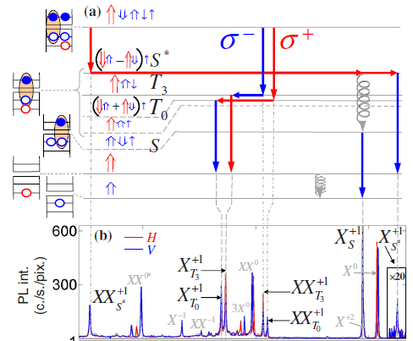

*PRB 81, 085306 (2010)*

Also, both holes are of a heavy hole type.

Moving away from SK QDs to pyramidal QDs with expected C3V (or higher) symmetry, K. F Karlsson *et al* (*New J. Phys.* **17** 103017, 2015) shows that the energetic structure and selection rules can be very different when compared to the established picture of SK dots. Importantly, in a good agreement with our experimental work, they have an excited hole of a light-hole type. In their notation and figure below, the hot/excited trion is X+11.

The fine structure is calculated here using group theory (page 13 introduces the basics). Page 17 (and Fig 17) addresses the hot/excited trion case:

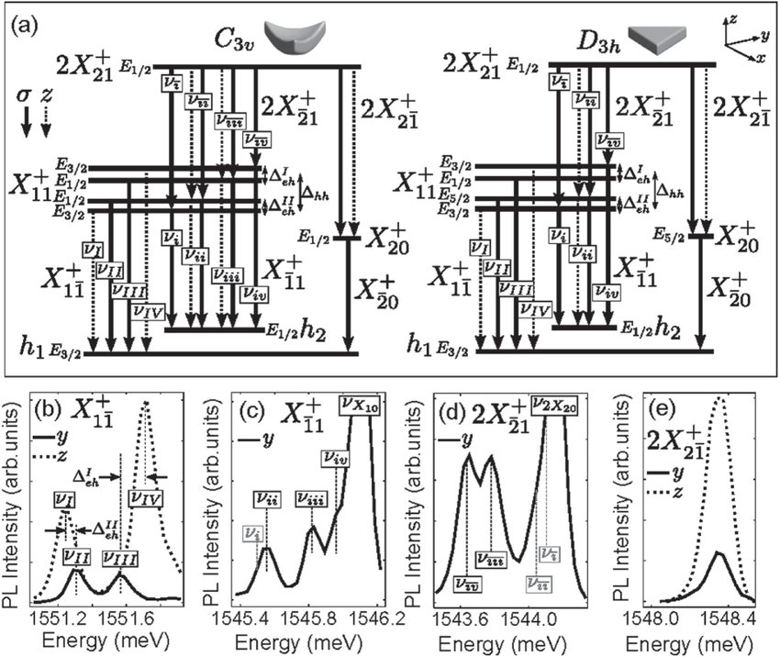

If we look to the case of C3V symmetry, the ground transition would have all 4 components optically active and 2 in-plane. It is a big difference from the SK dot picture. An excited transition should be composed of two in-plane and two out-of-sample/QD-plane components.

Here is where things get confusing and what we would like to understand. It is not clear what is represented by the introduced state notations E3/2, E1/2, E1/2, E3/2, i.e. the actual configuration of spin and orbital parts. Intuitively and in analogy to the SK dot model, it seems that the index represents the total sum of the angular momenta (z projections) of the trion-composing particles. If it is so, then in C3V case, for example, the state with 5/2 is missing which would represent all aligned spins (+1/2 electron, +3/2 heavy-hole, +1/2 light-hole) – the D3h case has such. In SK dots such state exists as one of the triplets and it’s dark. If such state here does not exist, is there an intuitive way to explain why? Also, as there are 2x E3/2, and 2x E1/2 states, it would mean that at least two states have exactly the same spin configuration. If so, what is different – is it the orbital part?

As the symmetry breaks, they show that in principle all components in all directions become optically active (Fig. 20):

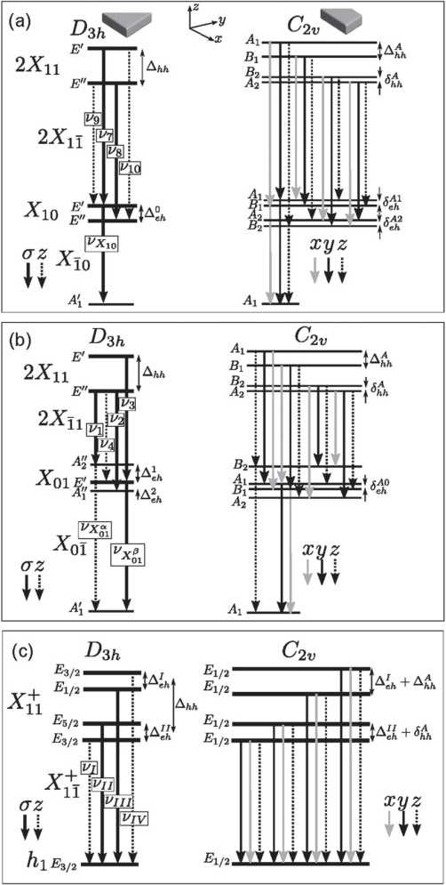

Interpretation of our experimental work strongly suggests that we observe results which are different from a known SK dot model. We always have very clear 3 transitions form the ground state and 4 optically active excited state resonances. The excited states typically have two inner transitions brighter in-plane (marked as z). The picture is not the same as the theory predicts but it is different from SK dots.

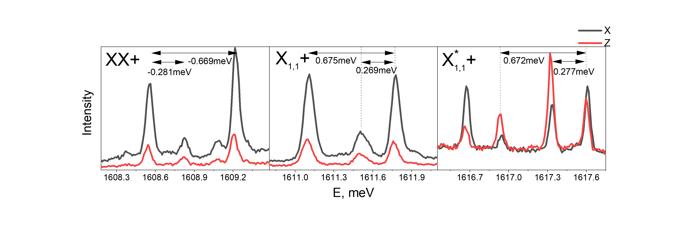

Regarding spin configurations, by using resonant excitation of the excited trion states and performing polarization-resolved correlations of trion-related emission, we can probe QD-occupying spin dynamics. As the laser polarization state can be mapped to the polarization state of trion-related states (a nice feature we have as the hole states are very little mixed), by performing correlations we can see in what state the occupying hole is after the first recombination event, i.e. projection of the spin state. We can gain very useful information, but there is an exeption in one case where we observe that no matter what, we find hole with an opposite spin after the projected measurement. In SK QD picture, it is hard to explain without any sort of exotic spin flipping events which are possible but not really fitting in this context. For our discussion, we need to understand how the spin configurations can change if we have a different symmetry group.